Resume

Abhishek Manu
New streets
kannur, ST 12345
9061776802
4bhishekmanu@gmail.com

Skills
Python, Flask,django, SQL, HTML, CSS, JavaScript

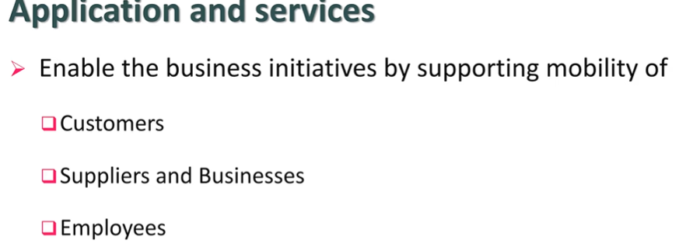

Experience

February 2025 - August 2025

TCS, Kochi - engineer
- Lorem ipsum dolor sit amet, consectetur adipiscing elit.
- Aenean ac interdum nisi. Sed in consequat mi.
- Sed in consequat mi, sed pulvinar lacinia felis eu finibus.

Education

November 2020 - June 2024

College of engineering thalassery, kannur - Btech computer science
Lorem ipsum dolor sit amet, consectetuer adipiscing elit, sed diam nonummy nibh euismod tincidunt ut laoreet dolore.

